Creating a Sprite
Know the difference between a sprite and a sprite sheet!

- Go to https://www.piskelapp.com/
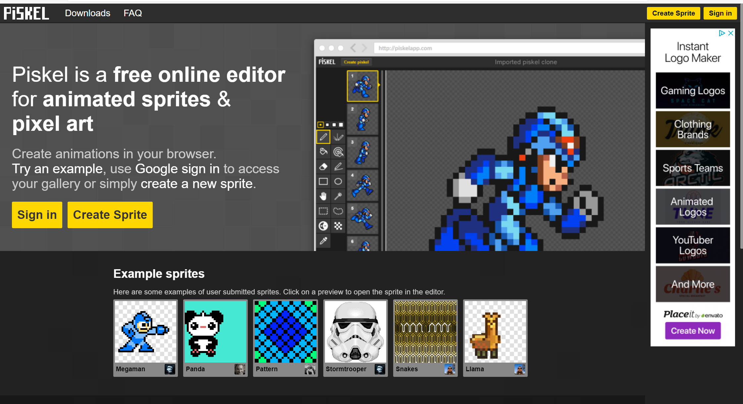
- Sign in with a Google Account.
- Choose create sprite

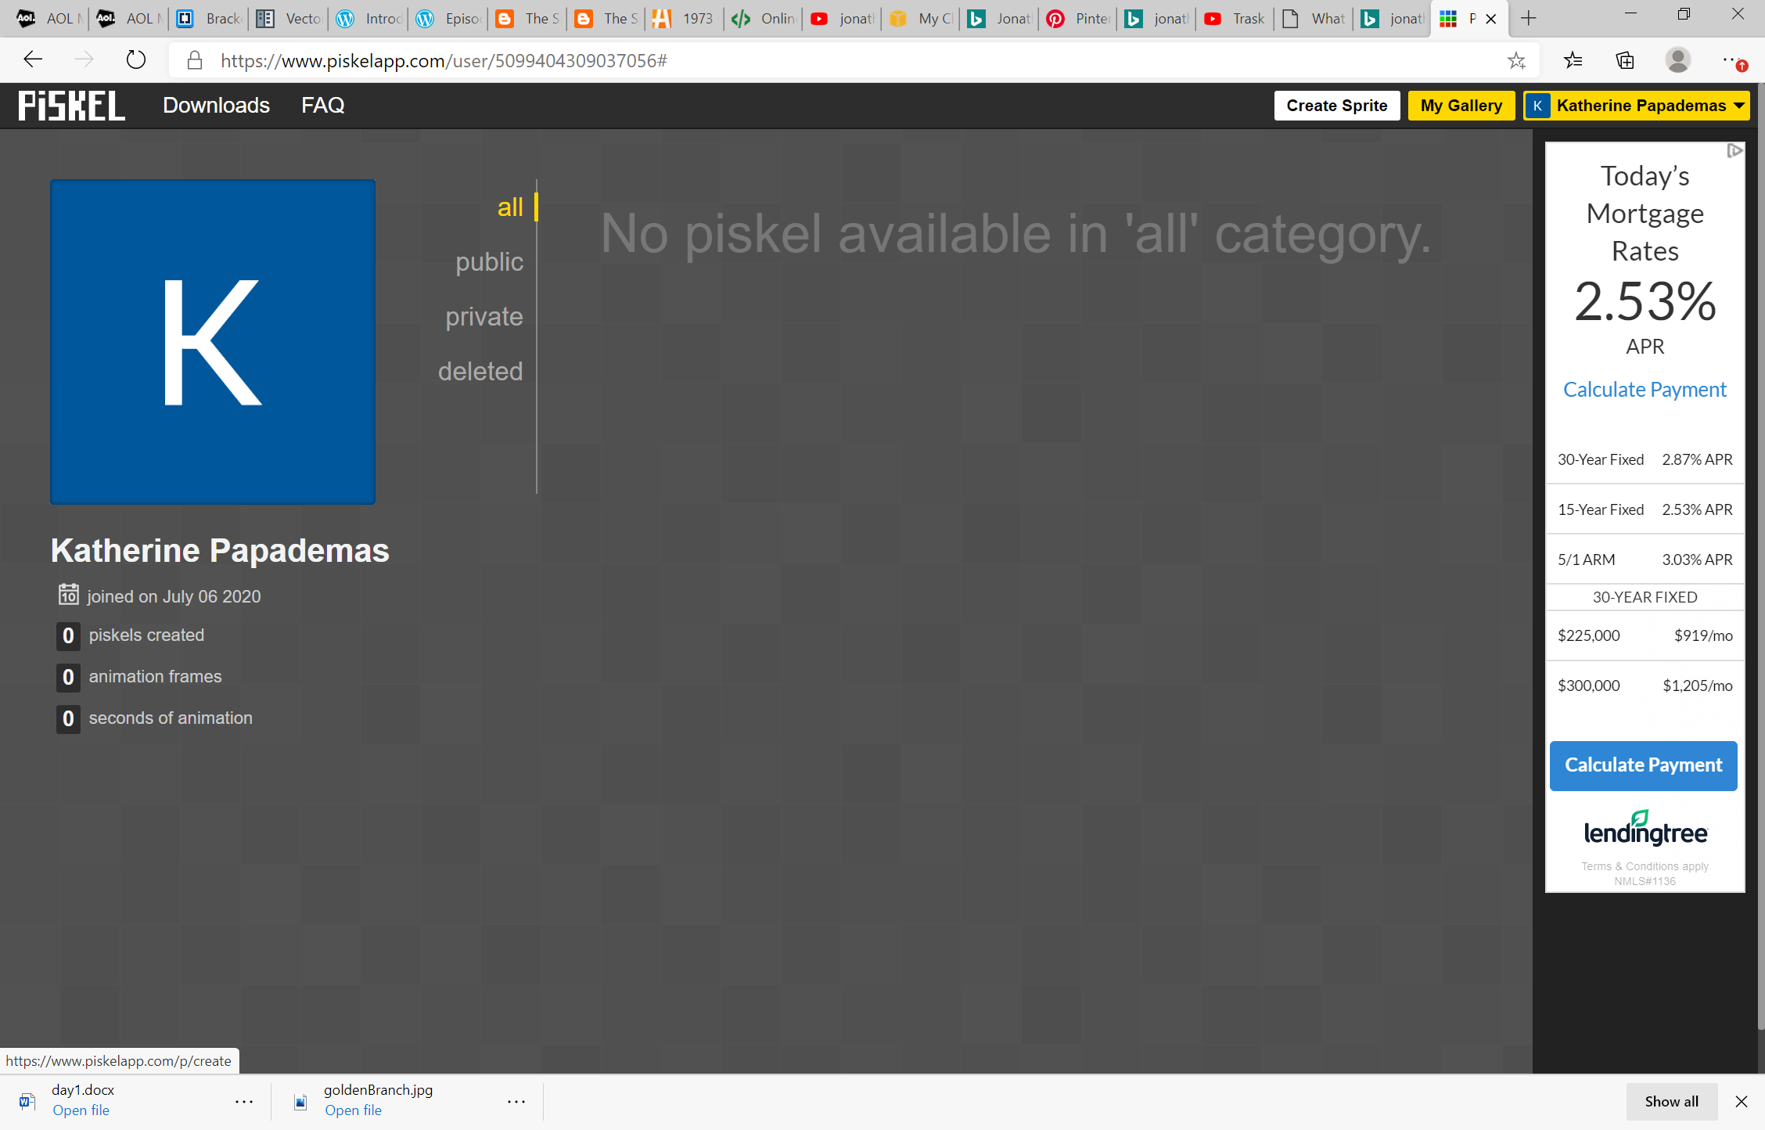

- The screen should appear as …
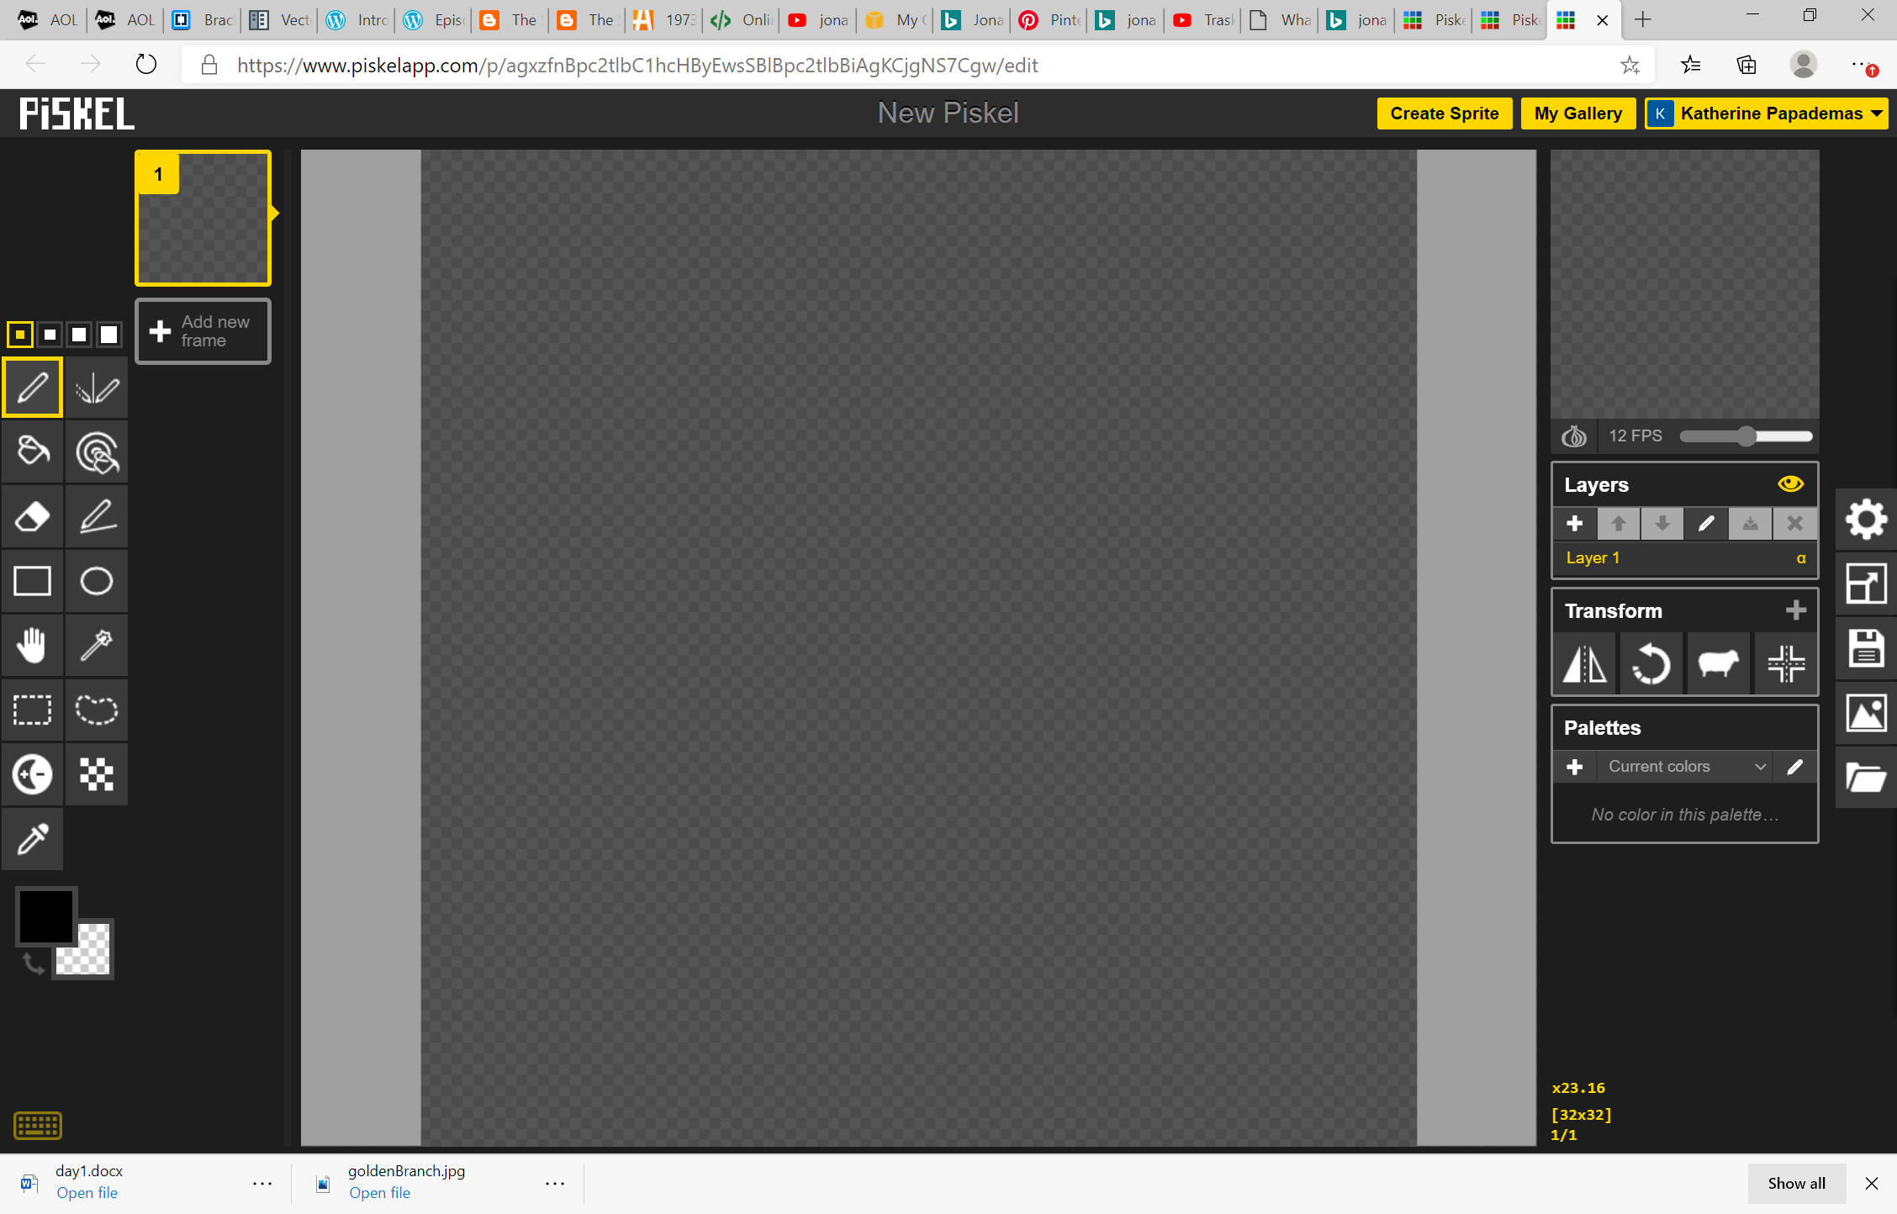
- Familiarize with the tools on the left panel and the options on right pane .

- Save the sprite:
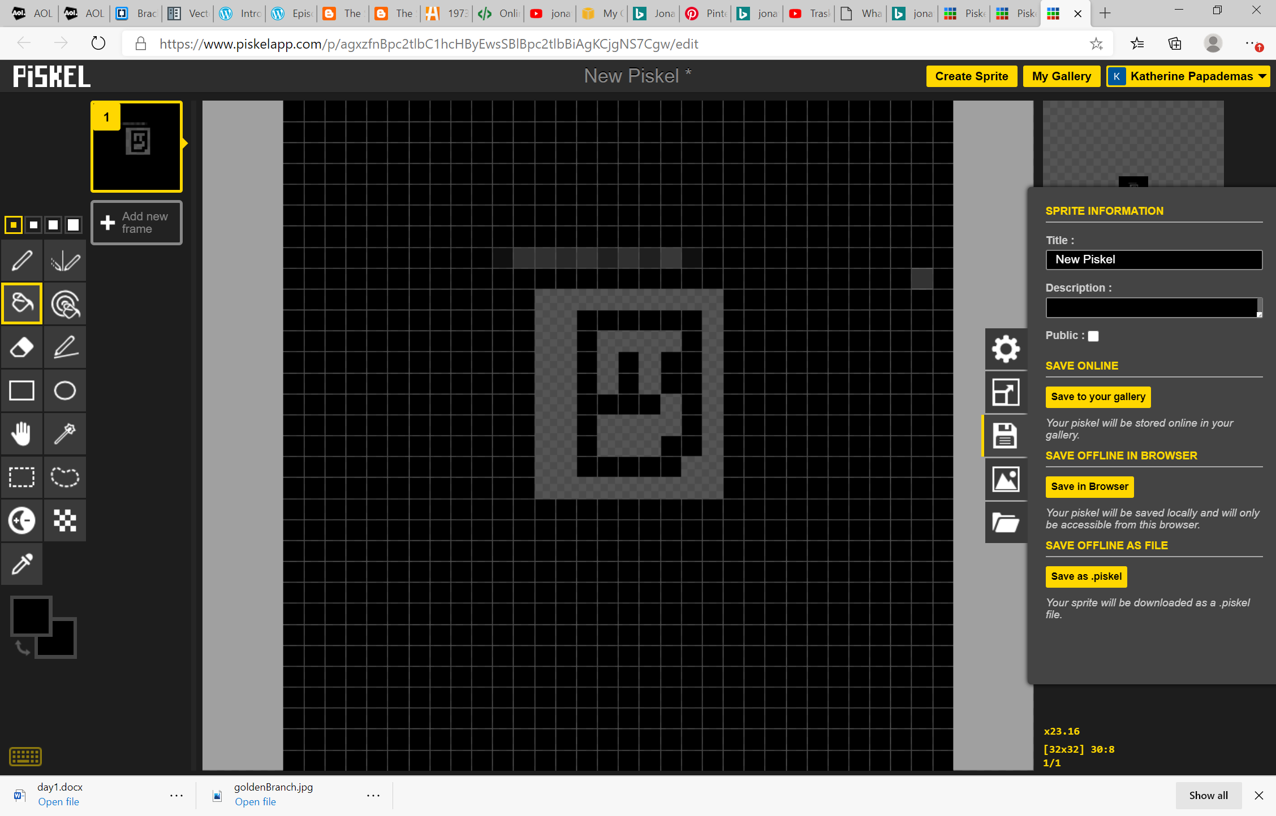

- Creating a pallete of colors
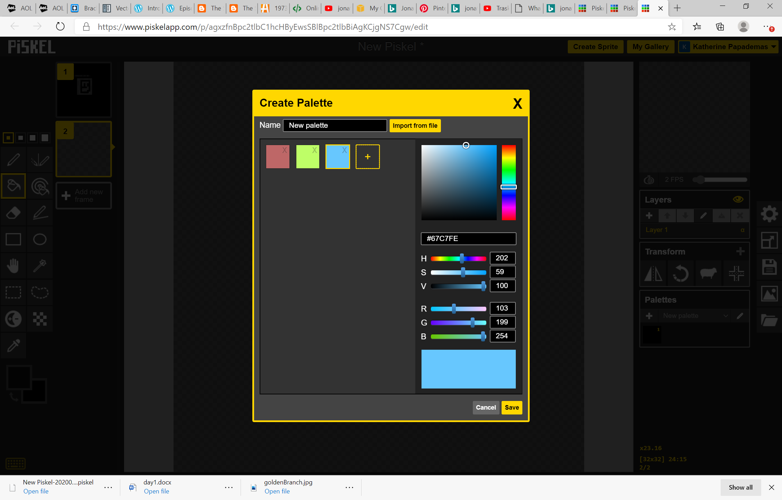
HSV -> Hue Saturation Value
RGB -> Red Green Blue 255 255 255 = white 0 0 0 = black
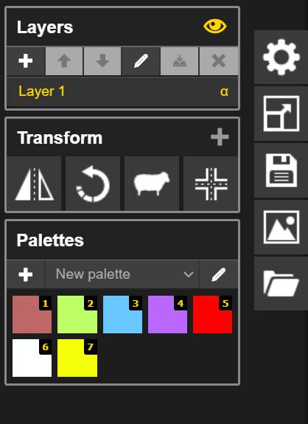

- Layering

====
https://sketch.io/sketchpad/
